Course Description  This course will cover American history 1945-1968, exploring through documents and primary sources the key political, social, cultural, economic, and intellectual developments of the era. Topics will include the evolution of liberalism amidst the threat of the Cold War, the transformation of the political parties, the development of new state organizations as America assumed its role as a global superpower, explore the implications of the Cold War on cultural affairs, including the evolution of youth rebellion and youth culture, the expanded role of the presidency in politics, and the rise of new forms of political culture and the role of the media in American politics.  ABOVE: Free Speech Movement at the University of California – Berkeley, 1964  Figure 1 Above: The Free Speech Movement at the University of California-Berkeley, 1964  Course Policies  Academic Integrity: Citation, writing clarity, and grammar are important in making your argument effective and understandable. I suggest you visit this site to review writing skills and techniques and that you make use of FSU’s Writing Center to review your work, particularly if you have concerns. Please note that ignorance is not an excuse for plagiarism. Students are responsible for understanding and adhering to the university’s policies regarding plagiarism and academic integrity. The consequences for violation are severe, including failure of the course and potential expulsion.  Email: is the best way to reach me. Please be aware that it may take me up to 24 hours on weekdays and 48 hours on weekends to respond. If you do not hear back from me, it is likely that the answer is available on the syllabus. If your email issue takes more than a paragraph to explain, please come see me in my office hours.  Late Policy: Late papers and assignments will only be accepted by prior arrangement. Late work will receive a penalty of one-third grade deduction per day late (i.e. an A becomes an A- after one day, and so on).  Grading: All grading is done using FSU’s 4.0 scale. If you receive a numerical/percentage grade (e.g. 88%), it will be calculated using the corresponding GPA (3.3).  Fitchburg State encourages the full participation of individuals with disabilities in all aspects of campus living and learning. To support access and inclusion, Fitchburg State offers reasonable accommodations to students who have documented disabilities (e.g. physical, learning, psychiatric, sensory, etc.). If you require accommodations for this class, please provide me with a copy of your Accommodation Agreement as soon as possible so that we can discuss your specific needs. Any information that you share with me will be held in the strictest confidence, unless you give me permission to do otherwise. If you require academic accommodations but do not have an Accommodation Agreement, contact Disability Services a.s.a.p. to establish your eligibility: www.fitchburgstate.edu/disability or 978-665-4020.  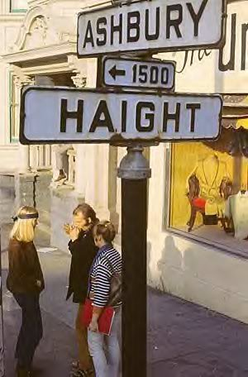 | Objective  History students are adept in grammatical writing, document construction, oral communication, use of evidence to construct persuasive arguments, and possess the ability to think through problems from multiple perspectives and through the eyes of people of different backgrounds and experiences.  Contact  Professor Katherine R. Jewell  Office: Miller 301-B  Office Hours: Tues/Thurs 10:30-12  kjewell1@fitchburgstate.edu  Course Logistics  Meeting Time: Tues/Thurs 12:30-1:45  Classroom: Percival 210  Key Experiences  Reconstructing historical events based on multiple, sometimes conflicting points of view  Evaluating the origins of current political parties  Reading and evaluating scholarly articles  Reading and evaluating a historical monograph  Reading, watching, and evaluating works of fiction as historical documents  Connecting and differentiating historical and current events in the United States  Core Questions  This course revolves tightly around six sets of guiding questions. These questions will serve as the basis for all class readings, discussion, exams, and paper topics.  - Were the 1950s a period of political and cultural consensus, or a period of extended conflict?  - Did products of the media and mass culture in the 1950s and 1960s (select examples) reflect an era of prosperity and general consensus, or contain evidence of growing dissent, the presence of inequality, and/or conflict?  - How did the civil rights movement challenge dominant patterns of post-World War II America, in politics and culture? How did it replicate certain patterns?  - How do you explain the successes and failures of the civil rights movement? What moments produced the most change, what leaders and what members of the movement were most influential? What were its failures?  - Who challenged the political and cultural status quo in the 1960s, and did they succeed? How would you categorize these challengers, and what methods and strategies did they use?  - How did this era transform American life? Consider politics, society, intellectual life, economics, foreign policy, and culture.  Required Books and Films  Required Books  Jack Kerouac, On the Road  Bruce J. Schulman, Lyndon B. Johnson and American Liberalism (Bedford St. Martin’s Reader)  Bloom and Breins, Takin' it to the Streets  Nicole Hemmer, Messengers of the Right  Freedom Summer (Bedford St. Martin’s Reader)  Required Films  There will be screenings and movies will be available on reserve in the library, or find on Netflix/streaming.  Rebel without a Cause  Primary  Berkeley in the Sixties  The Graduate

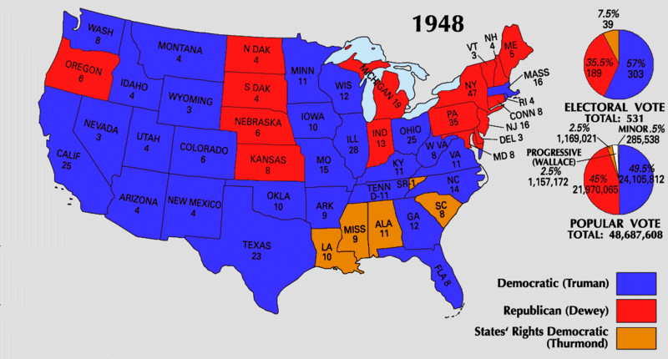

Competencies and Learning Objectives
Students in history develop skills valuable to their future success. In this class, we will be engaging in activities with the aim of meeting competencies as defined by the American Historical Association (https://www.historians.org/teaching-and-learning/tuning-the-history-discipline/2016-history-discipline-core, 2016):
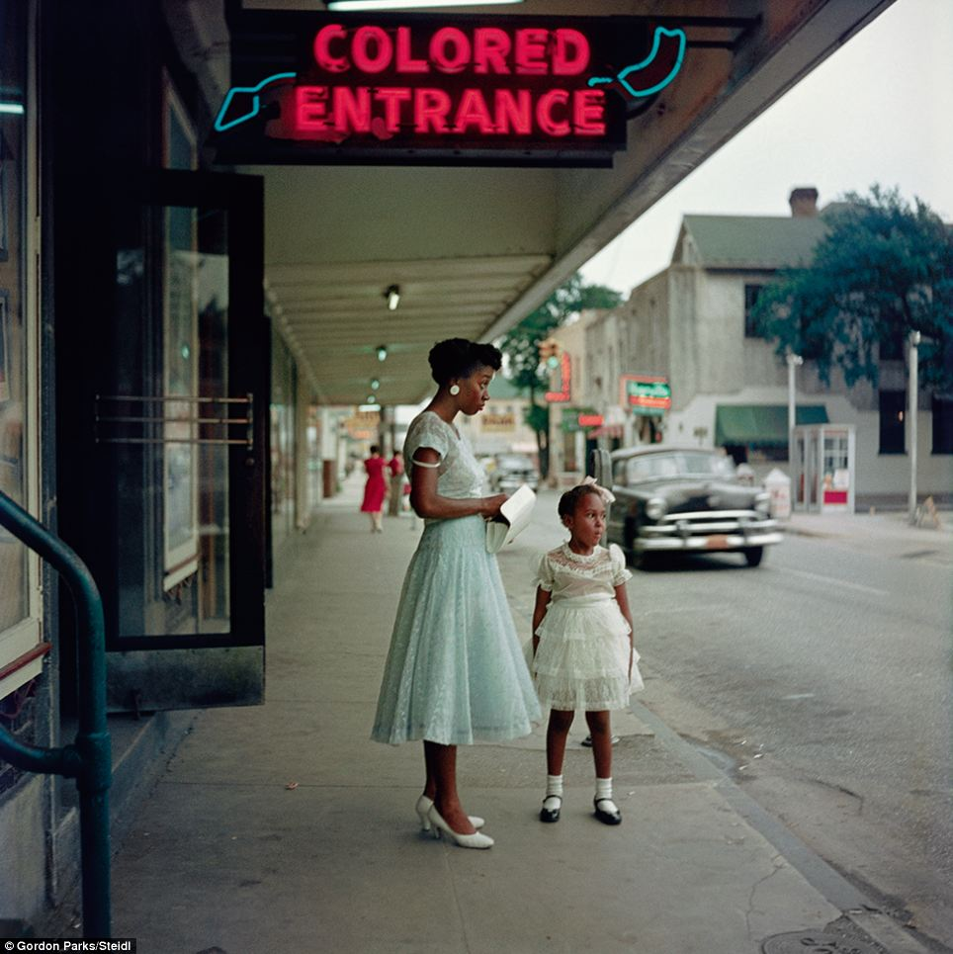
History students can:
- Build historical knowledge.
  - Gather and contextualize information in order to convey both the particularity of past lives and the scale of human experience.
  - Recognize how humans in the past shaped their own unique historical moments and were shaped by those moments.
  - Develop a body of historical knowledge with breadth of time and place—as well as depth of detail—in order to discern context.
  - Distinguish the past from our very different present.
- Develop historical methods.
  - Recognize history as an interpretive account of the human past—one that historians create in the present from surviving evidence.
  - Collect, sift, organize, question, synthesize, and interpret complex material.
  - Practice ethical historical inquiry that makes use of and acknowledges sources from the past as well as the scholars who have interpreted that past.
  - Develop empathy toward people in the context of their distinctive historical moments.
- Recognize the provisional nature of knowledge, the disciplinary preference for complexity, and the comfort with ambiguity that history requires.
  - Welcome contradictory perspectives and data, which enable us to provide more accurate accounts and construct stronger arguments.
  - Describe past events from multiple perspectives.
  - Explain and justify multiple causes of complex events and phenomena using conflicting sources.
  - Identify, summarize, appraise, and synthesize other scholars’ historical arguments.
- Apply the range of skills it takes to decode the historical record because of its incomplete, complex, and contradictory nature.
  - Consider a variety of historical sources for credibility, position, perspective, and relevance.
  - Evaluate historical arguments, explaining how they were constructed and might be improved.
  - Revise analyses and narratives when new evidence requires it.
- Create historical arguments and narratives.
  - Generate substantive, open-ended questions about the past and develop research strategies to answer them.
  - Craft well-supported historical narratives, arguments, and reports of research findings in a variety of media for a variety of audiences.
- Use historical perspective as central to active citizenship.
  - Apply historical knowledge and historical thinking to contemporary issues.
  - Develop positions that reflect deliberation, cooperation, and diverse perspectives.
History students are also adept in grammatical writing, document construction, oral communication, use of evidence to construct persuasive arguments, and possess the ability to think through problems from multiple perspectives and through the eyes of people of different backgrounds and experiences.

Course Schedule and Readings

Introduction

Class 1 | Thursday | Sept. 7
Introduction to the course and syllabus overview.

Legacies of WWII

Class 2 | Tuesday | Sept. 12

Read: Ensure you have access to all the books.

Harry S. Truman

Class 3 | Thursday | Sept. 14
Read: Schulman, pp. 5-56

McCarthyism and Cold War Culture

Class 4 | Tuesday | Sept. 19
Polenberg and May essays (PDFs on Blackboard)

Welcome to the Suburbs

Class 5 | Thursday | Sept. 21
Read: Marchand Documents on Blackboard

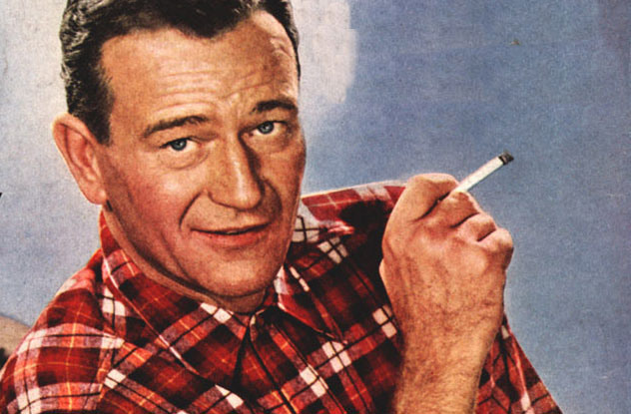

Suburban Dreams/Suburban Nightmares

Class 6 | Tuesday | Sept. 26

Read: Kerouac (first half); Freidan in Streets, p. 407

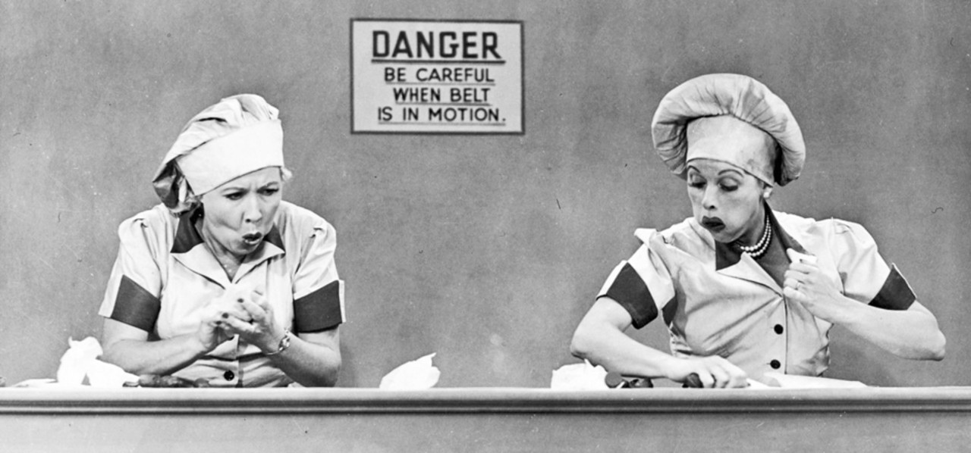

Teenagers and Rebels in the Fifties

Class 7 | Thursday | Sept. 28
Watch: Rebel without a Cause
Read: Hemmer, Introduction and Chapters 1-3 (Part I)
Watch: Rebel without a Cause (screening time TBA or on library reserve)

The Civil Rights Movement Arises

Class 8 | Tuesday | Oct. 3
Read: Schulman, pp. 104-124; Freedom Summer Introduction (Part I) start

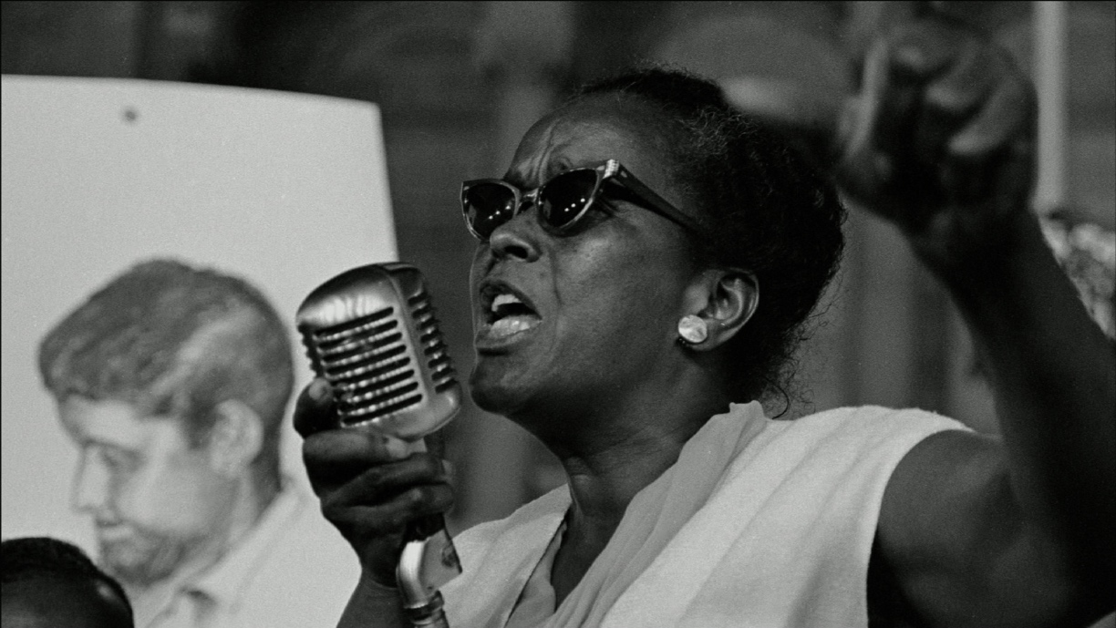

The Meaning of America in 1960

Class 9 | Thursday | Oct. 5
Read: Streets, pp. 12-51; Freedom Summer Introduction (finish)

Media and Politics and the 1960 Election

Class 10 | Tuesday | Oct. 10
Watch: Primary (screening TBD, also on library reserve)

Debating Civil Rights

Civil Rights Movement Discussion

Class 11 | Thursday | Oct. 12
Read: Streets, pp. 52-59; Two documents from Freedom Summer (TBD), skim the others
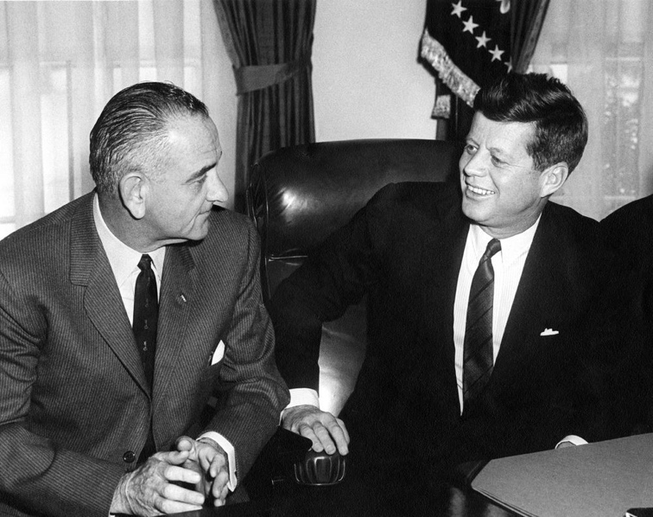

MIDTERM

Class 12 | Tuesday | Oct. 17

The Great Society and the War on Poverty

Class 13 | Thursday | Oct. 19
Read: Schulman, pp. 81-103; 165-191

Into the Quagmire

Class 14 | Tuesday | Oct. 24
Read: Streets, pp. 163-192; Schulman, pp. 125-154

Vietnam Discussion

Class 15 | Thursday | Oct. 26
Read: Streets, pp. 193-236

From Rebellion to Revolution

Class 16 | Tuesday | Oct. 31
Read: Streets, pp. 60-87; 97-114

The Right side of the Sixties

Class 17 | Thursday | Nov. 2
Watch: Berkeley In the Sixties (screening TBD)
Read: Streets, pp. 300-306; Hemmer, Chapters 4-6 (Part II)

Beneath Consensus

Discussion

Class 18 | Tuesday | Nov. 7
Read: Streets, pp. 307-316 (Conservatives);
Schulman, pp. 155-166; Hemmer, Chapters 7-9 (Part III)

Cultural Nationalism

Discussion

Class 19 | Thursday | Nov. 9
Read: Streets, pp. 119-162

The Silent Majority Speaks

Class 20 | Tuesday | Nov. 14
Read: Streets, pp. 307-312; 318-340

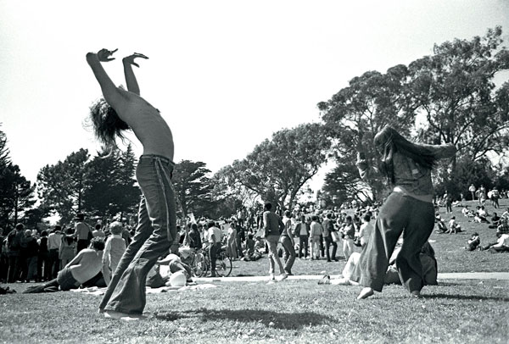

The Counterculture

Class 21 | Thursday | Nov. 16
Read: Streets, pp. 236-250; 266-293

1968 on Television

Class 22 | Tuesday | 21
Read: Streets, pp. 345-359; 368-395; 407-436; Schulman, pp. 233-245

No Class – Thanksgiving

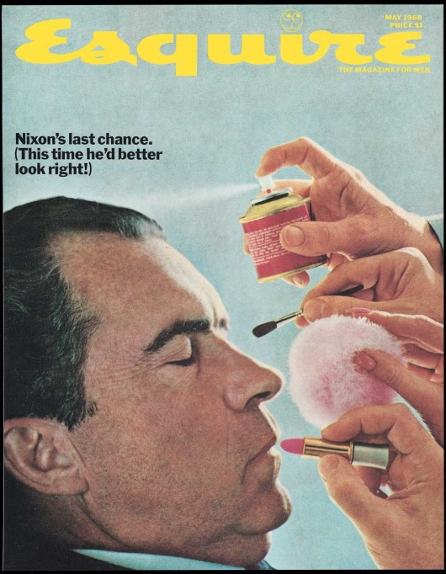

Chicago 1968

Class 23-26 | Nov. 28 – Dec. 7
Readings and Assignments TBA

Legacies of the Sixties

Class 25 | Tuesday | Sept. 12
Read: Streets, skim Chapter 9, chose one document to focus on;
Hemmer, Chapters 10-12 (Part IV) and Conclusion

Final Exam

